PASSWORD MANAGER HOSTED IN CLOUD

Getting started with Password Manager in Cloud

Deploy community version to AWS:

Generate Key Pairs:

Configure Passbolt after EC2 instance is up:

Password Manager HTTPS Configuration

Configure your domain with the ip address of Ec2//Domain: patssbolt.club linked to ec2 public ip

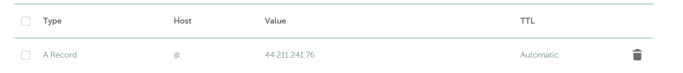

Setup Nginx for SSL

Connect to EC2 Instance from Kali Linux via ssh

sudo nano /etc/nginx/sites-enabled/nginx-passbolt.conf

sudo dpkg-reconfigure passbolt-ce-server

Click on the AWS Public IP link address

**Database configuration**

SMTP SERVER SETTINGS

Password generated and stored successfully in Password Manager:

